
Development Request
Aria Systems

NEW PROGRAM
Facility to create a cost sheet by Sales Order/Style

New Program Template Description

New Program Template
Product: | Aria 2.7
Module: | SO – Sales Order
Customer name: | Alena Ltd
Installed Modules: | AR, IC, SO, PO, SA, RM, SM, MA, SR, AP, GL
Parameters setting: | Multi-Currency = Y  Multi-warehouse = Y  Material Costing method = Lot  Style Costing method = FIFO  Extended sizes = No  Style number format = 12 characters style code  6 characters colour

Details Section
Screen Name: Sales Order Cost Sheet

Screen Objective: The customer needs a cost sheet by sales order/style to facilitate varying costs for a style for different customer orders

A Cost Sheet is required for each Sales Order/Style
A new file ORDBOM will be created to maintain the sales order/style Cost sheet details having the sales order number and the style as the main keys. In every other respect it will have the same information as the Style Cost Sheet BOM with some additional fields which are discussed in this specification
The new Cost sheet will be accessible from Options while in a Sales Order and also from a separate menu option under Transaction titled ‘Sales Order/Style Cost Sheet’

A new screen is required which will contain some default costings. The screen will be headed ‘Default Costings’
The screen will prompt the user to specify a default percentage for three categories of Duty namely, IPR, OPR and EUR. Duty is set up as a separate cost item in Setups as is defined as cost type 4 in BOM.
The screen will also prompt for a default rate for the Manufacturing Operation ‘MATERIAL LOSS’. CODES.CDISCREP = MATERIAL LOSS
These default costs will be held in a new file titled BOMDEF
The normal rules ie. Edit, save etc will apply to this screen

Screen example

Default Costings

Duty IPR Rate 14.00 (user keys in the rates for each item)
OPR Rate 13.00
EUR Rate 12.00

Material Loss Rate 5.00

The Sales Order/style Cost Sheet processing will work as follows:-

The user will key in a new sales order through Transaction – Sales Order – Sales order as normal. When the user has finished processing the details of the Sales Order and clicks on the Save icon, the sales order number is then assigned.
The system will then check if a previous ORDBOM record exists for the style(s) on the sales order or if not a Style Cost sheet BOM. NOTE: There will usually be only one style on a sales order but there may sometimes be multiple styles where sizes exceed 8 or where additional styles need to be created to facilitate multi-dimensional sizing such as leg lengths etc.
Case 1:
The system finds that all styles on the Sales order have a sales order/style cost sheet (ORDBOM) record or Style cost Sheet (BOM) record

The system will first look for the latest ORDBOM record for the styles/colours on the SO. If not ORDBOM record exists then it will look for BOM records. It will copy the ORDBOM /BOM data from the latest record available in the system for the style to create a new ORDBOM/BOM record for each SO/Style. It will do this for each style and obviously for each colour on the sales order. The sales order for a style may contain less style colours than there are on the original ORDBOM/BOM record. The system will only copy the ORDBOM/BOM record to ORDBOM for the colours which exist on the Sales Order.
Having picked up the ORDBOM records, the screen will then automatically load the Cost Sheet front screen for the first style on the sales order
The normal arrow icons will be available at the top of the screen with the option to scroll to the next style cost sheet for the next style on the order

The Sales Order Cost sheet screen will look and work like the current BOM input screen with the following exceptions.

1. The user should be allowed to overwrite the exchange rates applicable to each cost item (Ex rate field) if the cost items are in foreign currency. The exchange rate should then be saved in the ORDBOM file against each cost item ORDBOM.EXRATE. If the user accesses an existing Sales Order/Style Cost sheet, there should be a prompt ‘Update Exchange rates’. No should be the highlighted option. If the user responds No to this prompt, then the previously saved exchange rates should be retained. If the user responds Yes, then the exchange rates will be updated to the latest available exchange rates in the system for each cost item.
For cost items which are Fabric and trims, type= 2 or 3, the user will not be able to edit the Ex rate field on the screen. Instead the user should be able to edit the exchange rate applicable to the item by clicking on the new option item titled ‘Amend Foreign prices.’ (See point 3)

2. The sales order number will appear at the top of the screen together with the style number.

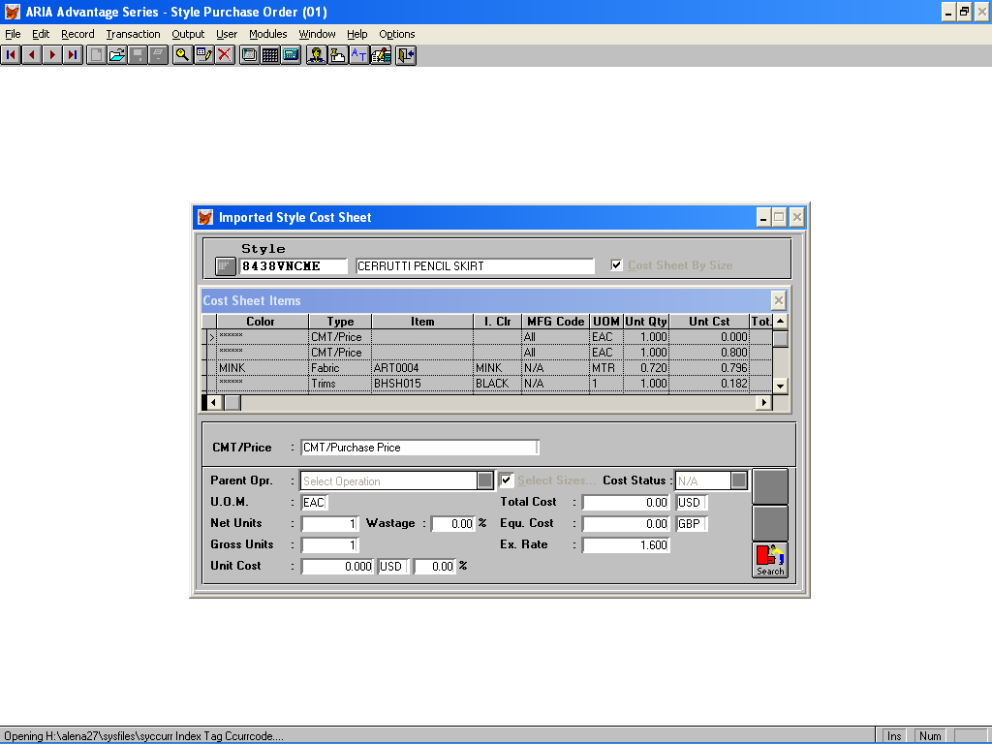

3. On the standard Style Cost Sheet, fabric and trim items are shown as the total unit cost in the base currency. The user needs to be able to change the buying prices of fabric or trims some of which may be in Foreign currency. If FABRIC.CPRICECUR = GBP, the user can amend the price in the standard Unit Cost field. This amended price will then update ORDBOM.UNTCOST and TOTCOST and the user will not have access to the Ex Rate field.
However, if the FABRIC.CPRICECUR <> “GBP”, then the user should not be allowed to amend the Unit Cost field but should instead be allowed to amend the foreign price on a separate field. Add the option ‘Amend Foreign Price/Duty Rates to Options on the Cost Sheet screen. If the user highlights a Purchase price or Manufacturing operation item ie type <> 2 or 3, then the user will not be able to edit the Foreign price but will be able to edit the Duty rate (see point 5). If the user highlights a fabric or trim item and clicks on Options-Amend Foreign Price/Duty Rates the screen will display the existing foreign price and exchange rate and the user will be able to overwrite and save. The new foreign price should be updated to a Field in ORDBOM i.e.
ORDBOM.FXCOST

Amend Foreign Price/Duty rates

Price USD 3.25
Exchange Rate 1.600
Duty Rate 14.00

Save Close

The screen should show the currency code also i.e. FABRIC.CPRICECUR. The user will also be able to amend the Exchange rate related to this item. Having amended the Foreign price (NFABCOST) and exchange rate and saved, the system will then update ORDBOM.UNTCOST as follows:-
If FABRIC.CPRICECUR <> GBP and FABRIC.CDUTYCUR = GBP
(((ORDBOM.FXCOST/ ORDBOM.EXRATE)/FABRIC.CONV)+(NMCOST2+MNCOST3+NMCOST4)/FABRIC.CONV),
If FABRIC.CPRICECUR = FABRIC.CDUTYCUR and are not =GBP
(((((ORDBOM.FXCOST/ ORDBOM.EXRATE)/FABRIC.CONV)+(NMCOST2+MNCOST3+NMCOST4)/ORDBOM.EXRATE)/FABRIC.CONV),

See point 5 for an explanation on the duty rates

4. The standard BOM allows only one Primary fabric for a style. ORDBOM will allow different Primary fabrics for different colours of a style and different primary fabrics for the SAME colour of a style. For example, style 8924, Colour BLACK may have Primary fabric F21333, colour Black and F09455, colour black.
To facilitate the assignment of multiple primary fabrics for an existing style cost sheet, the check box ‘Set as Primary fabric’ should be available for editing on the front screen of the Sales Order Cost sheet.
There is some spare space to fit this in to the right of the Unit Cost field

When copied from ORDBOM/BOM, the fabric which has already been defined as the Primary fabric will have the check box already displayed. The user will then be able to click on the ‘Set as Primary fabric’ check box to assign other fabrics as primary fabrics. Should more than one fabric be assigned as Primary for a style/colour, the system will automatically divide the Net units (rating) equally across however many fabrics are assigned. For this purpose another field should exist on the screen above titled Total Primary fabric Costing (or something similar) into which the total costing would be keyed and maintained as the total for all Primary fabrics for that style/colour. This field would only be accessible where the ‘Set as Primary fabric’ box has been ticked and would only be editable on the first Primary fabric specified for the Style/Colour
For example, Fabric F12345, Colour BLACK has been assigned as the Primary fabric to Style 9856, Black and the net units shown is 1.20. The field ‘Total Primary Fabric Costing also shows 1.20. The user ticks another Fabric, Fabric F7894, Colour BLACK as a primary fabric also related to the same style/colour. Irrespective of the current Net units already displayed for the second fabric, the 1.20 on the first fabric will now be divided equally between the two fabrics and both will show a net units of 0.60. The total net units 1.20 will appear on the screen against each of the fabrics in the field Total Primary fabric costing and will be written to ORDBOM into a separate field PRIMUNT_QTY which will appear against each fabric which has been assigned as a Primary to the style/colour.
The logic field PRIMARY will be added to ORDBOM to show the assignment of multiple fabrics as Primary

5. When displaying the existing ORDBOM the Duty and Material Loss cost items will automatically be loaded with Material Loss picking up the default % from the Default costings but showing zero Unit cost. The user can amend this percentage as required. The Duty will show both the % and unit cost as zero. The user will click on the Duty cost item and there will be a new option under Options titled Duty Type. When the user clicks on this the user will be allowed to select one of three options IPR/OPR or EUR. and select the relevant duty type i.e. IPR, OPR or EUR. Once selected this will default the duty % to the relevant % for that cost type but this rate can be overwritten for each cost item/ category

As the user keys in each cost item, the Cost Status drop down option needs to have the following options:-
N/A
Duty
Material Loss
Both

The existing options should be removed. For the Duty cost item it should be possible to select any one of the options except Duty. For the Material Loss cost item it should be possible to select any one of the options except Material Loss. For the fabric and trim cost items the default cost status will be Both. ORDBOM.CCOSTSTAT should be updated with a number representing the relevant selection i.e. 1 = Duty, 2 = Material Loss, 3 = Both, Blank = N/A.
For each cost item which has Cost Status Duty or Both, the Duty % will be displayed according to the duty category selected against the duty cost item. This will be displayed on the Options- Amend Foreign Price/Duty rate. It will be possible to overwrite the duty rate for each item, if required. If the duty rate is overwritten for one of the trims, for example, the user will be prompted , Update rate for all items’ If Yes the new duty rate will then be used for all cost items in that category with Cost status Duty or Both. If no, the user will be able to specify different duty rates for each item in the category. These duty rates should be written to a separate field in ORDBOM. ORDBOM.DUTYRATE
When calculating the Duty and Material Loss unit costs, the system will check the cost status applied to the cost of each item and calculate based on the percentage which has been automatically picked up or in the case of duty which may be variable, the calculation will be based on adding all items of the same duty % together and calculating the duty amount. The calculation of the duty amount will be written to the Unit Cost field of the Duty cost item. If the Duty percentages are variable, an average percentage will be displayed in the % field. It should be possible to overwrite the duty % against any cost item and it should be possible to overwrite the duty category selected against the duty cost item (from options- Duty Type). It should not matter if the style purchase price currency is different from the duty currency. Where this is the case, the costs will be converted to base currency using the exchange rates which have been specified when entering the costing i.e. from ORDBOM.EXRATE for the relevant cost items and then the Duty and/or Material Loss percentages will be applied to the converted cost. The Duty Category selected should be written to a new field in ORDBOM- DUTYCAT
6. When entering fabric on the Style Cost sheet, the width field FABRIC.WIDTH should be displayed on an Option item titled ‘Fabric Width’ which will display FABRIC.WIDTH for the cost item being highlighted. The user will be able to edit this if required and the system should update to ORDBOM.WIDTH
All other processing will be as for the standard style cost sheet (BOM) and the user will be able to add/remove material or non-material cost items as standard. When the user has edited the copied the record and saves, the system will create the ORDBOM record for the sales order/style. The system will also overwrite where possible, the standard BOM record with any amendments which have been made on the sales order cost sheet (ORDBOM). On saving, the user can proceed to the next style cost sheet on the sales order using the right arrow key at the top of the screen and again the BOM will be copied over and the user can edit the necessary fields and save.

On saving of the Sales order cost sheet for the style the total cost for each colour on the style based on the ORDBOM costs for each colour should be written to ORDLINE.COST

When all the style cost sheets have been completed for the sales order, the user can close the program or refresh the screen ready for the next sales order.
If the user wishes to return later to edit a cost sheet record on a sales order, the user can key in the sales order number in Transaction – Sales Order – Sales Order and click on the Edit icon
(The user can also use the separate menu option on Sales Order – Transactions, titled ‘Sales Order/Style Cost sheet’ where the user can access the Sales order cost sheet by keying in the sales order number and then browsing and selecting the style to view. It should be possible to create new ORDBOM records from this option or amend existing records in the same way as from the Sales Order Options menu)

If accessing from the Sales Order - Options item, the user will then click on the Details folder tab and click on the style to be viewed or amended. The user will then click on Options and select the option ‘Sales Order Cost Sheet’. The cost sheet front screen for the style highlighted will then be displayed and the user can edit as previously discussed. The arrow key can be used to scroll through the cost sheets for any other styles on the Sales Order or alternatively the user can Close the Sales Order Cost Sheet screen and highlight another style on the Details screen and click on Options-Sales Order Cost Sheet.

Case 2
A Style cost sheet does not exist for one or more styles on the sales order.
If, on saving the sales order, the system finds that a style cost sheet does not exist for one or more styles or colours on the sales order, the system will prompt ‘Style Cost Sheet for Style 451245 does not exist’ or Style Cost Sheet for style 451245, Colour BLACK does not exist’ Do you want to create a cost sheet now Yes/No.

If the user selects No at this point the system will display the style cost sheet record for any style on the sales order which HAS a cost sheet so that the user can amend as discussed previously. If no cost sheets are present then the screen will be refreshed ready for a new sales order. The user can then return to the sales order later to add any missing cost sheets. Each time the user saves the order and where there is a missing cost sheet, the message will be displayed. The user will be able to repeatedly ignore it by replying No. However, when generating the PO Cost Sheet, the system will not be able to create the PO Cost Sheet if any ORDBOM records are missing so the user will need to create the Sales Order Cost Sheet at this point at the latest.
If the user selects Yes, in response to the Style Cost Sheet does not exist’ message, the style cost sheet front screen for the first style with a missing cost sheet will be loaded on the screen with the details blank. The user will then click on Edit and the options, Add, Copy or Cancel will be displayed as for the standard Style Cost Sheet.

‘Copy’ will allow the user to select the style cost sheet (BOM) from which to copy. The Selection of items to copy will work in the same way as for the standard cost sheet but the system will ensure that it only copies for style colours on the sales order.
‘Cancel’ will abort the cost sheet creation as standard
‘Add’ will allow the user to create a cost sheet from scratch as for the standard style cost sheet.
When the user is adding Fabrics to the style cost sheet (BOM.TYP)=2, the user can tick the Set as Primary Fabric for multiple fabrics as discussed previously. If there are two fabrics to be set as a primary fabric for the same style colour, the user will do the following:-
Key in the first fabric , tick set as primary fabric, and select the colour assignment e.g. Style colour different from fabric colour, key in the net units (rating) in the new field ‘Primary fabric costing’, this will update the Net Units field with the same figure.
The user will then (or later) key in the second fabric, tick ‘set as primary fabric’ and select the style/fabric colour assignment for the same style/colour as the previous fabric. The net units field will automatically take the Primary fabric costing as entered on the first fabric and divide by 2 to get the net units for the second fabric. The first fabric net units will now also be half of the ‘Primary fabric costing’
If a third Primary fabric is added for the same style/colour, the Total Primary fabric costing will then be divided by three and the net units for each of the 3 fabrics will be recalculated accordingly.

The remainder of the processing will be as for points 1-6 already detailed in this specification.
When the style cost sheet for the first style is saved, the screen may display a message indicating that another style on the sales order has no style cost sheet. If that is the case the user can follow the procedure as explained for the first style. The user can use the arrow to flick through the style cost sheets to ensure that a cost sheet exists for each style on the order before saving.

When adding new Fabric and Trim items to the cost sheet the option ‘Fabric color same as Style color’ or Trim color same as style color’ appear as the default

Change this so that the default always appears as ‘Style color uses different fabric color’ or ‘Style color uses different trim color’

